Sentaurus setup manual

EE312 17-18 winter

1. Introduction

There are many ways to access Sentaurus work station by your own terminals. This manual only provides one which TA finds working relatively convenient. For off-campus students, you need first connect VPN before the following steps. Also keeping your computer online is needed during the simulation running.

**For Windows:**

1. Software download/setup

2.1 Download the three following softwares:

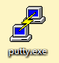  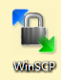

1. Putty, an SSH client, which could be downloaded at [www.putty.org](http://www.putty.org)
2. Xming, an X server, which can be downloaded at sourceforge.net/projects/xming/
3. WinSCP, which can be downloaded at winscp.net/download/winscp576setup.exe

(WinSCP is very powerful tool to edit/switch files between your computer and workstation)

(Attention: Make sure all the three software above you downloaded matches your computer configuration (32/64-bit). Otherwise it will not work.)

* 1. Install all the three software according to the instructions respectively

1. Running simulation

3.0 On Xming

Open the “Xming .exe” file, it will pop up a vacant window, you could minimize it on the right bottom riceer of your desktop, but DO NOT close it, keep it running.

3.1 On the Putty

Open the Putty, then the following window pops up:

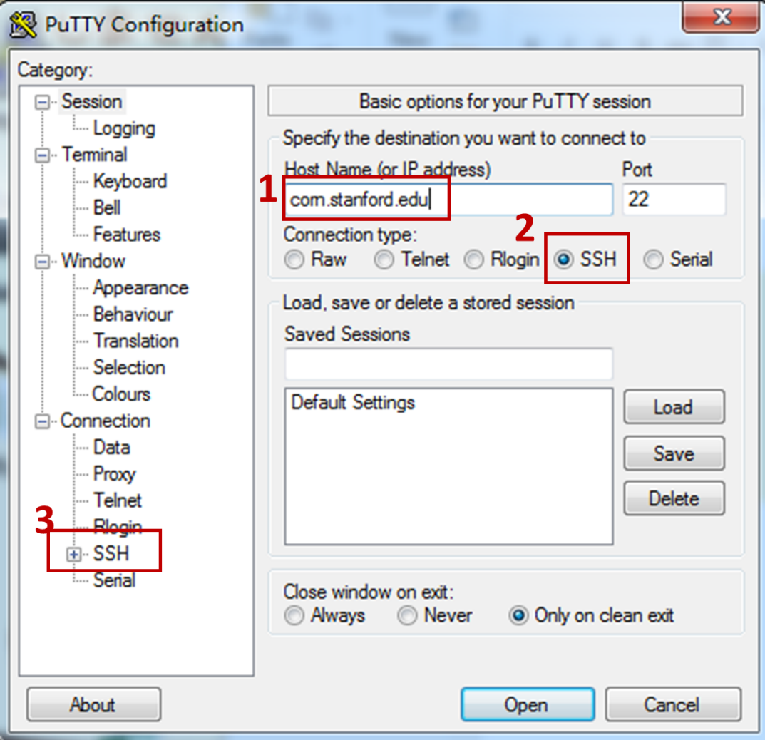

rice.stanford.edu

Type in “rice.stanford.edu” in the host name region. Check the SSH item.

Then open the branch of SSH. The window will change to the following:

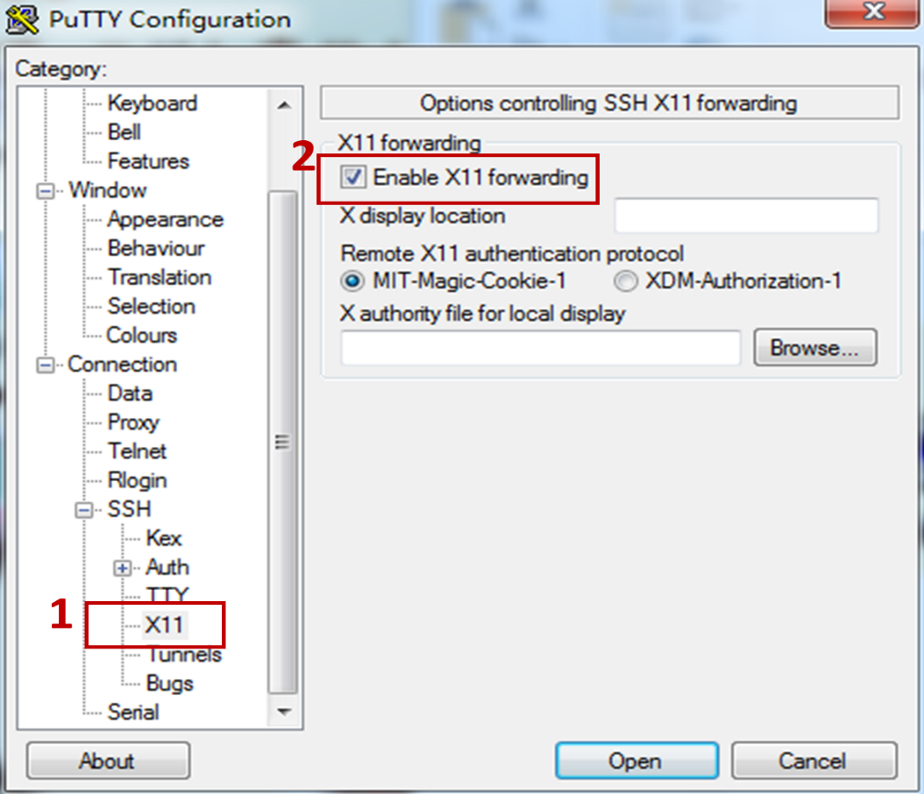

Single click the “X11” item within the “SSH” branch. CHECK the “enable X11 forwarding” on the right side of the window. (You need to do the steps above every time when you login Putty, you could also save the settings above as your default settings).

Then click “open” item, the real user interface appears, which needs you to log in. Your login ID and the password are exactly the same as your Axess. (It may also need two-step authentication sometimes). You are log-in state now.

* 1. **Initialization (Just for first-time running simulation, also needed for MAC users!)**

Open WinSCP.exe file (or Fetch for Mac users). Type in “rice.stanford.edu” in the host name region. User name and password are the same as Axess.

Now you should be able to see all your files under your default folder in the work station. Download the following two files from canvas and put it into your home directory using WinSCP: synopsys_setup.sh, test.cmd

Now go back to the Putty command window, type in:

bash

Then type in

source synopsys_setup.sh

Now you finish the initialization. (If your computer returns error after you type in “source synopsys_setup.sh” command, go to step 3.3. Otherwise directly go to step 3.4)

* 1. Check display mode

In the Putty window, type in:

printenv DISPLAY

It will return your **local ID**,then type in:

xhost rice.stanford.edu

Finally type in

setenv DISPLAY <local ID>

The local ID is exactly what tour computer returns

3.4 Check whether you could run a simulation

Type in

sprocess test.cmd

test.cmd is an example Sentaurus file. You could easily exchange files between your computer and workstation through WinSCP, just by copying and paste!

Note: Name extension of the example file name is “.cmd”. Only the “.cmd” files could be run by Sentaurus. This kind of file can be opened in your computer by writing pad just like a “.txt” files. You could manually change the extension from “.cmd” to “.txt” when you need to edit the file. But remember you need to change the extension back to “.cmd” when you transfer the file back to workstation, to run the Sentaurus simulation.

Note: make sure your Putty interface and the “.cmd file” you want to run are under the same directory. Otherwise it will return no such file in directory. You could check your current Putty directory by “ls” command, or change your current Putty directory by “cd foldername” command.

If your Putty window starts checking the syntax, followed by popping up the simulation log data, you are all set.

**For Macs**

Mac OS X based systems require Xquartz (formally X11) to launch the terminal. It is included with recent versions of the operating system and can be specified as an option when installing OS X, or else installed at a later time using a separate package located on the OS X installation media (i.e., the OS X DVD or Install Disc). It is also available for download at the [Apple website](http://www.apple.com/support/downloads/x11formacosx.html). (<http://xquartz.macosforge.org/landing/>). Before following each steps below, you need to first download an SCP/SFTP client for Mac (WinSCP is for Window only). We recommend Fetch, offered for free for Stanford students here: <https://uit.stanford.edu/software/fetch>. After successful download of Fetch, refer to **section 3.2** for initialization (similar as windows users).

* 1. Verify that Apple X11 is installed and launch the X11 application (located in the Utilities subfolder of the Applications folder).  
       
       
     A **xterm** window should open by default. If no terminal window opens, start one by selecting **Terminal** from the **File** menu or pressing **command-N**.  
       
     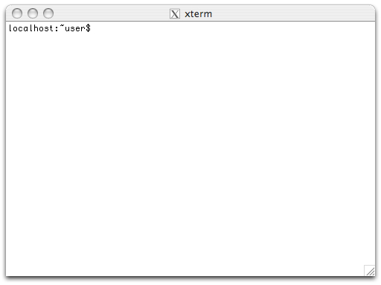

4.2 At the **$** prompt, run the OpenSSH client using the **ssh** command. This command takes a single argument specifying the user's SUNet ID and the target host, and requires a single option, **-Y**, specifying that ssh should additionally arrange for an X-windows connection; for example:   
  
ssh –Y *sunetid*@rice.stanford.edu  
  
If you are using OS X 10.3, it may be necessary to use **-X** instead of -Y:   
  
ssh -X *sunetid*@rice.stanford.edu

4.3 After entering a password the remote machine will present a standard UNIX prompt. Remote applications with a graphical user-interface will automatically use the local display.

* 1. You can now run TSENTAURUS PROCESS by issuing the command:

sprocess <*your_input_filename*>

4.5 To end the remote display session, quit all running UNIX applications, type **exit** to close the ssh connection, and quit the X11 application.

This manual is made up based on class notes from 14-15 fall quarter EE212 and 15-16 winter quarter EE410 and updated in Winter 2018.